# ------------------------------------ rf_friedman_mse_15 ------------------------------------

Pre-predictions:

timestamp percentage_current rainfall_current

0 2023-03-06 07:05:00 0.002989 0.0

1 2023-03-06 07:10:00 0.218467 0.0

2 2023-03-06 07:15:00 0.671000 0.0

3 2023-03-06 07:20:00 0.917933 0.0

4 2023-03-06 07:25:00 1.231933 0.0

5 2023-03-06 07:30:00 1.518200 0.0

6 2023-03-06 07:35:00 1.705867 0.0

7 2023-03-06 07:40:00 1.335400 0.0

8 2023-03-06 07:45:00 1.022533 0.0

9 2023-03-06 07:50:00 0.907267 0.0

10 2023-03-06 07:55:00 1.230333 0.0

Metrics for this specific prediction:

Accuracy: 99.99%

Mean squared error: 0.10497907927134441

Variance (R²) score: 1.00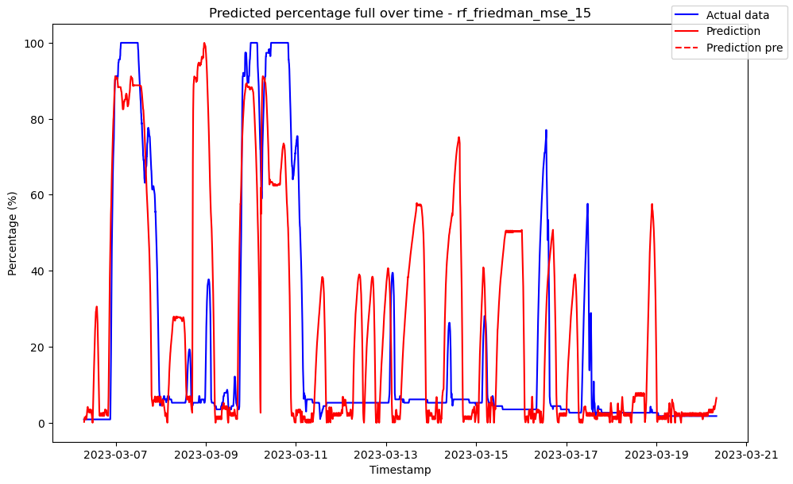

# ------------------------------------ rf_friedman_mse_2 ------------------------------------

Pre-predictions:

timestamp percentage_current rainfall_current

0 2023-03-06 07:05:00 0.0 0.0

1 2023-03-06 07:10:00 0.0 0.0

2 2023-03-06 07:15:00 0.0 0.0

3 2023-03-06 07:20:00 0.0 0.0

4 2023-03-06 07:25:00 0.0 0.0

5 2023-03-06 07:30:00 0.0 0.0

6 2023-03-06 07:35:00 0.0 0.0

7 2023-03-06 07:40:00 0.0 0.0

8 2023-03-06 07:45:00 0.0 0.0

9 2023-03-06 07:50:00 0.0 0.0

10 2023-03-06 07:55:00 0.0 0.0

Metrics for this specific prediction:

Accuracy: 99.99%

Mean squared error: 0.12309242951983816

Variance (R²) score: 1.00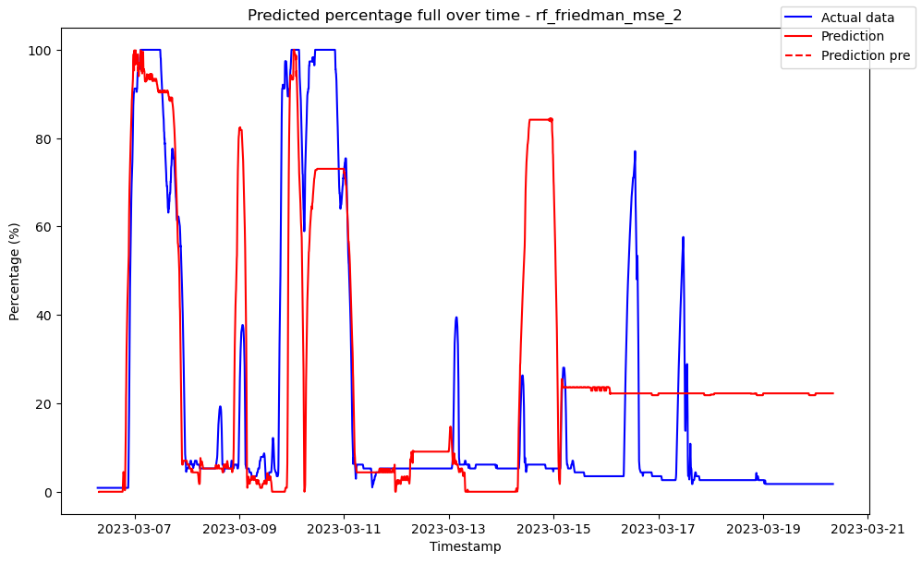

# ------------------------------------ rf_friedman_mse_22 ------------------------------------

Pre-predictions:

timestamp percentage_current rainfall_current

0 2023-03-06 07:05:00 0.002038 0.0

1 2023-03-06 07:10:00 0.242318 0.0

2 2023-03-06 07:15:00 0.541545 0.0

3 2023-03-06 07:20:00 0.831273 0.0

4 2023-03-06 07:25:00 0.724682 0.0

5 2023-03-06 07:30:00 0.471455 0.0

6 2023-03-06 07:35:00 0.220273 0.0

7 2023-03-06 07:40:00 0.088091 0.0

8 2023-03-06 07:45:00 0.360091 0.0

9 2023-03-06 07:50:00 0.563500 0.0

10 2023-03-06 07:55:00 0.761409 0.0

Metrics for this specific prediction:

Accuracy: 99.99%

Mean squared error: 0.11493247991132942

Variance (R²) score: 1.00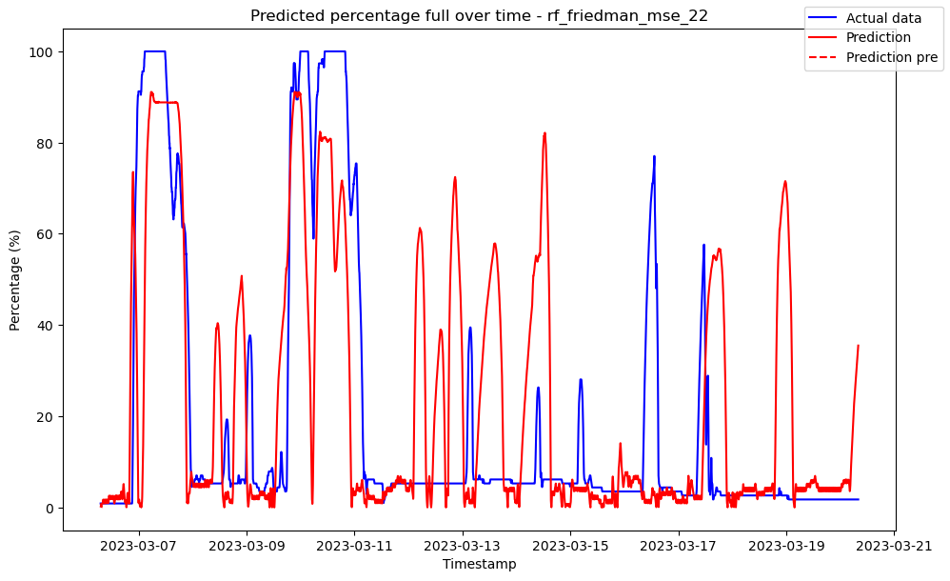

# ------------------------------------ rf_friedman_mse_38 ------------------------------------

Pre-predictions:

timestamp percentage_current rainfall_current

0 2023-03-06 07:05:00 0.002191 0.0

1 2023-03-06 07:10:00 0.233789 0.0

2 2023-03-06 07:15:00 0.545000 0.0

3 2023-03-06 07:20:00 0.822605 0.0

4 2023-03-06 07:25:00 0.747289 0.0

5 2023-03-06 07:30:00 0.453816 0.0

6 2023-03-06 07:35:00 0.161947 0.0

7 2023-03-06 07:40:00 0.044711 0.0

8 2023-03-06 07:45:00 0.398500 0.0

9 2023-03-06 07:50:00 0.690289 0.0

10 2023-03-06 07:55:00 0.860421 0.0

Metrics for this specific prediction:

Accuracy: 99.98%

Mean squared error: 0.20163131014823021

Variance (R²) score: 1.00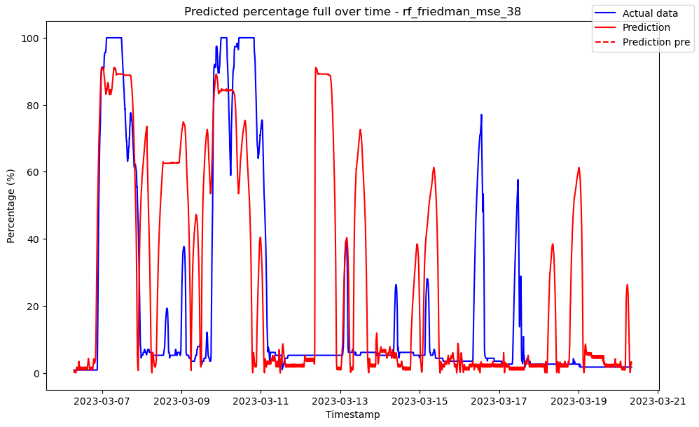

# ------------------------------------ rf_friedman_mse_4 ------------------------------------

Pre-predictions:

timestamp percentage_current rainfall_current

0 2023-03-06 07:05:00 0.0 0.0

1 2023-03-06 07:10:00 0.0 0.0

2 2023-03-06 07:15:00 0.0 0.0

3 2023-03-06 07:20:00 0.0 0.0

4 2023-03-06 07:25:00 0.0 0.0

5 2023-03-06 07:30:00 0.0 0.0

6 2023-03-06 07:35:00 0.0 0.0

7 2023-03-06 07:40:00 0.0 0.0

8 2023-03-06 07:45:00 0.0 0.0

9 2023-03-06 07:50:00 0.0 0.0

10 2023-03-06 07:55:00 0.0 0.0

Metrics for this specific prediction:

Accuracy: 99.99%

Mean squared error: 0.11162869763755323

Variance (R²) score: 1.00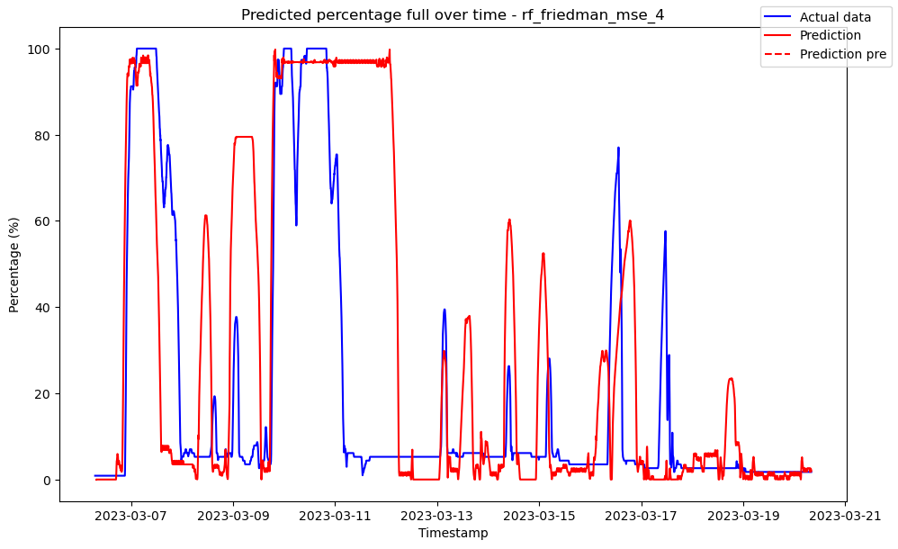

# ------------------------------------ rf_friedman_mse_55 ------------------------------------

Pre-predictions:

timestamp percentage_current rainfall_current

0 2023-03-06 07:05:00 0.001514 0.0

1 2023-03-06 07:10:00 0.220964 0.0

2 2023-03-06 07:15:00 0.692436 0.0

3 2023-03-06 07:20:00 0.992509 0.0

4 2023-03-06 07:25:00 1.632345 0.0

5 2023-03-06 07:30:00 1.666618 0.0

6 2023-03-06 07:35:00 1.329127 0.0

7 2023-03-06 07:40:00 1.031273 0.0

8 2023-03-06 07:45:00 0.933764 0.0

9 2023-03-06 07:50:00 1.261400 0.0

10 2023-03-06 07:55:00 1.649800 0.0

Metrics for this specific prediction:

Accuracy: 99.98%

Mean squared error: 0.18364850218853124

Variance (R²) score: 1.00